**ASL - ALPHABET IMAGE RECOGNITION**

**PROJECT REPORT**

**1. INTRODUCTION**

1.1 Project Overview

1.2 Purpose

**2. LITERATURE SURVEY**

2.1 Existing problem

2.2 References

2.3 Problem Statement Definition

**3. IDEATION & PROPOSED SOLUTION**

3.1 Empathy Map Canvas

3.2 Ideation & Brainstorming

**4. REQUIREMENT ANALYSIS**

4.1 Functional requirement

4.2 Non-Functional requirements

**5. PROJECT DESIGN**

5.1 Data Flow Diagrams & User Stories

5.2 Solution Architecture

**6. PROJECT PLANNING & SCHEDULING**

6.1 Technical Architecture

6.2 Sprint Planning & Estimation

6.3 Sprint Delivery Schedule

**7. CODING & SOLUTIONING**

7.1 Feature 1

7.2 Feature 2

7.3 Database Schema (if Applicable)

**8. PERFORMANCE TESTING**

8.1 Performance Metrics

**9. RESULTS**

9.1 Output Screenshots

**10. ADVANTAGES & DISADVANTAGES**

**11. CONCLUSION**

**12. FUTURE SCOPE**

**13. APPENDIX**

Source Code

GitHub & Project Demo Link

**1. INTRODUCTION**

**1.1 Project Overview**

The goal of the "Sign Language Recognition using Deep Learning" project is to create an approachable, real-time system for identifying gestures in American Sign Language (ASL). By utilizing TensorFlow and Keras to enable deep learning, the model can decipher a predetermined set of ASL signs, facilitating communication for those who are hard of hearing. The project's salient characteristics encompass resilient gesture identification in diverse settings, a user-friendly interface, and the possibility of ongoing enhancement via user input and supplementary training materials. The ultimate objective is to support the target audience—which includes educators, persons with hearing impairments, and those interested in sign language communication—in creating a more communicative and inclusive workplace.

**1.2 Purpose**

The purpose of the 'Sign Language Recognition using Deep Learning' project is to create an innovative solution that enables individuals with hearing impairments to communicate effectively through the recognition of American Sign Language (ASL) gestures.

**2. LITERATURE SURVEY**

**2.1 Existing problem**

Extensive research has been conducted on the recognition of American Sign Language (ASL) gestures with the goal of improving communication accessibility for those with hearing impairments. Previous research has identified a number of difficulties in this field. Robust recognition across a variety of environmental conditions, including different lighting and backdrops, is a major difficulty that can greatly affect the performance of recognition models. Furthermore, maintaining accuracy in real-time recognition presents a technological challenge. In certain situations, the feasibility of the state-of-the-art solutions is limited since they frequently call for substantial computational resources. This review of the literature dives into the current issues surrounding ASL recognition and provides the framework for a novel approach that tackles these issues.

**2.2 References**

<https://www.researchgate.net/publication/262187093_Sign_language_recognition_State_of_the_art>

<https://ieeexplore.ieee.org/document/9432296>

<https://github.com/Sri-Tulasi/VIT_Morning_Slot>

<https://www.sciencedirect.com/science/article/pii/S2666990021000471>

**2.3 Problem Statement Definition**Limited accessibility to American Sign Language (ASL) resources and education hinders effective communication for the deaf community. Our project aims to solve these challenges by implementing an ASL recognition system based on convolution neural networks (CNNs) to improve ASL accessibility and for better communication.

**3. IDEATION & PROPOSED SOLUTION**

**3.1 Empathy Map Canvas**An empathy map is a simple, easy-to-digest visual that captures knowledge about a user’s behaviors and attitudes. It is a useful tool to help us better understand our users. Creating an effective solution requires understanding the true problem and the person who is experiencing it.   
The users of our project would be deaf individuals who use ASL(American Sign Language) to communicate with others. We tried to put ourselves into various situations the deaf might experience and have completed the following empathy canvas map.

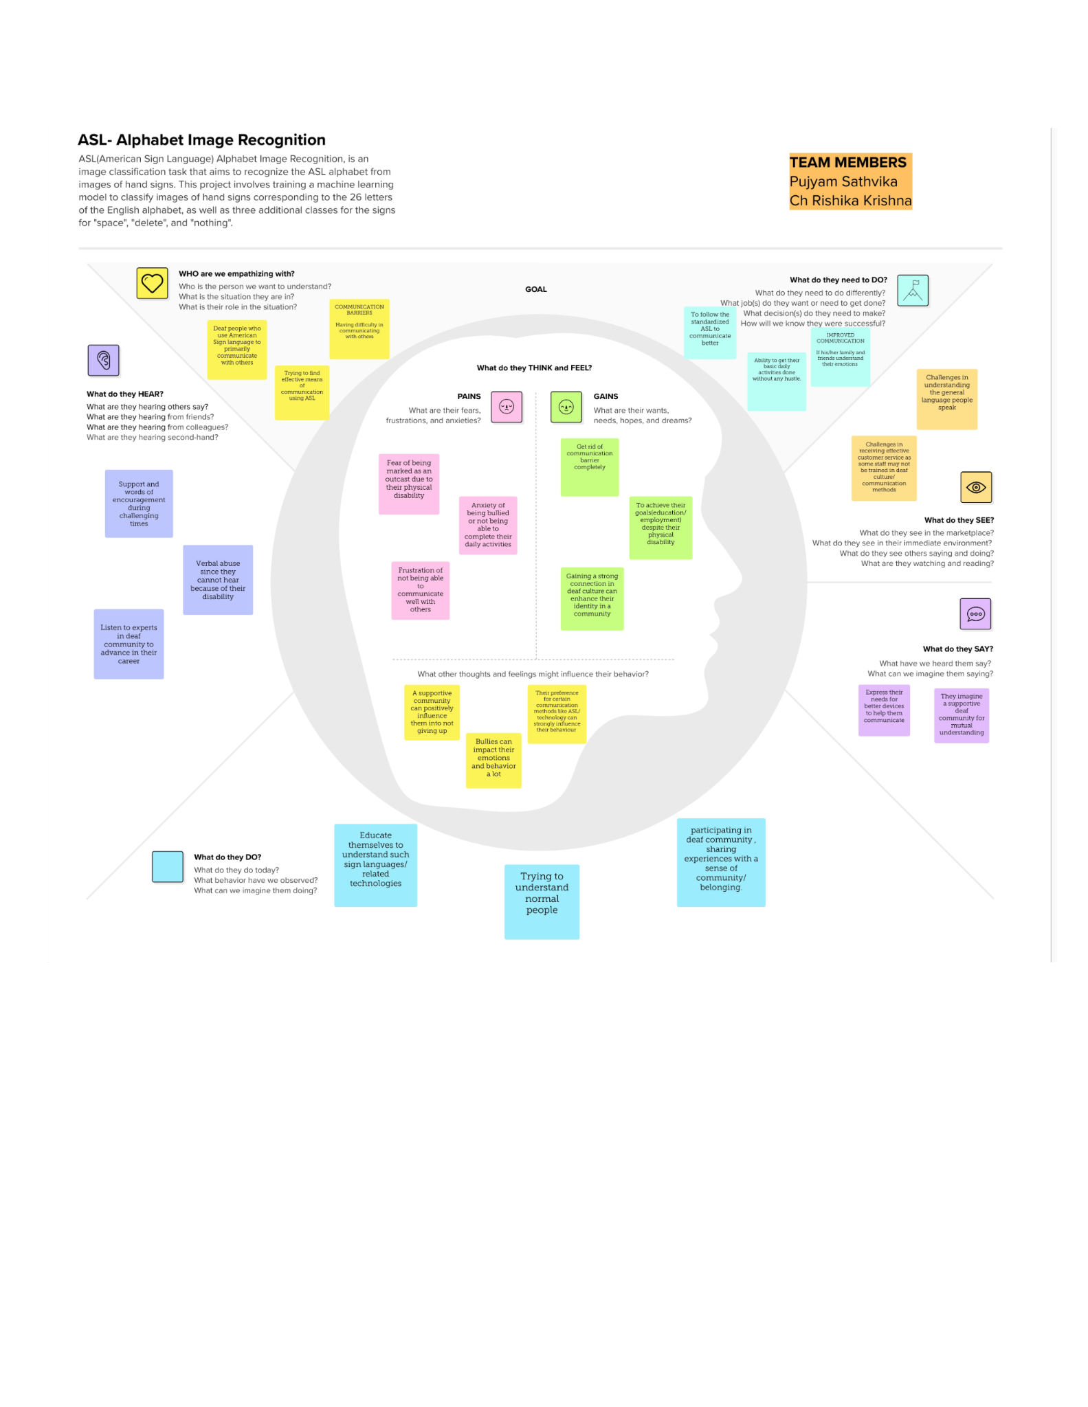

**3.2 Ideation & Brainstorming**Brainstorming provides a free and open environment that encourages everyone within a team to participate in the creative thinking process that leads to problem solving. Prioritizing volume over value, out-of-the-box ideas are welcome and built upon, and all participants are encouraged to collaborate, helping each other develop a rich number of creative solutions.  
Our problem statement was “How might we help deaf individuals communicate with the world in a better way?”  
The users of our project would be deaf individuals who use ASL(American Sign Language) to communicate with others. We tried to put ourselves into various situations the deaf might experience and tried to come up with various solutions for their problems, grouped the solutions and prioritized them to give us a better understanding of our users.

Step 1: Team Gathering, Collaboration and Select the Problem Statement

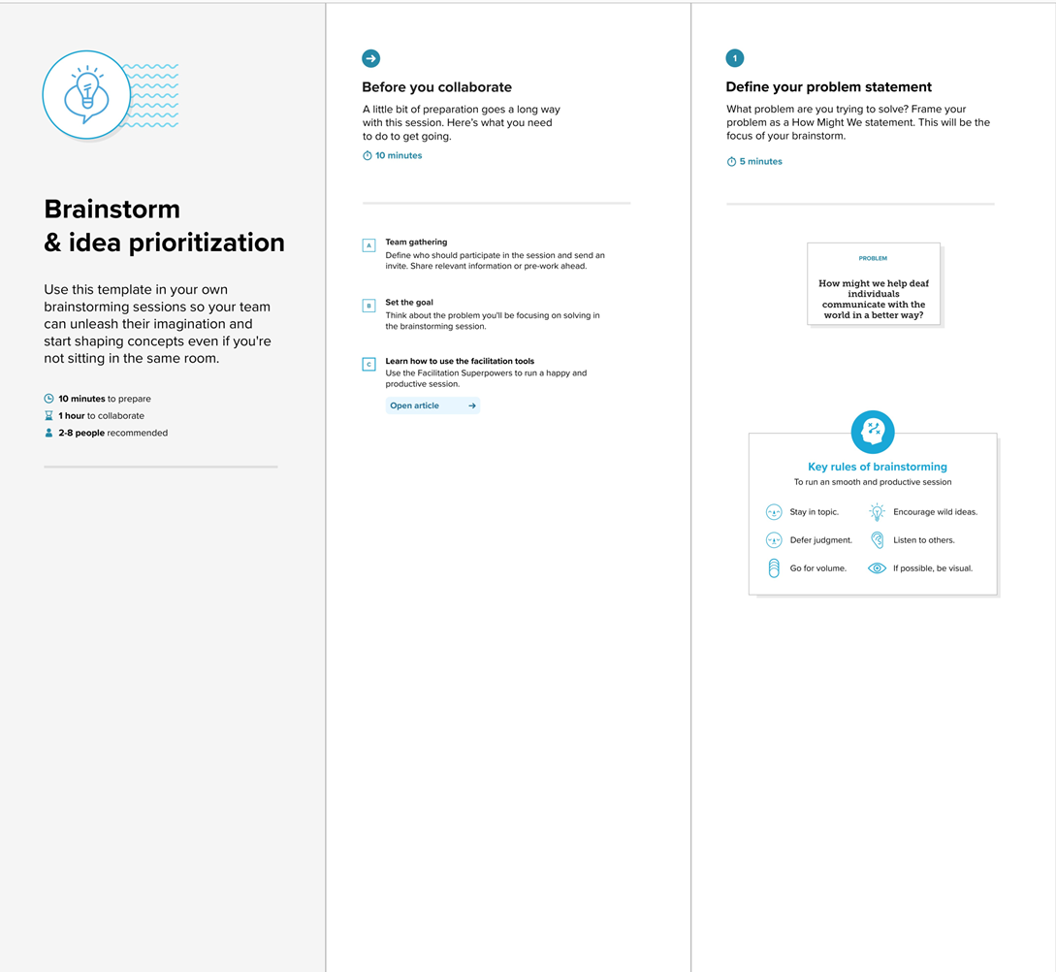

Step 2: Brainstorm, Idea Listing and Grouping

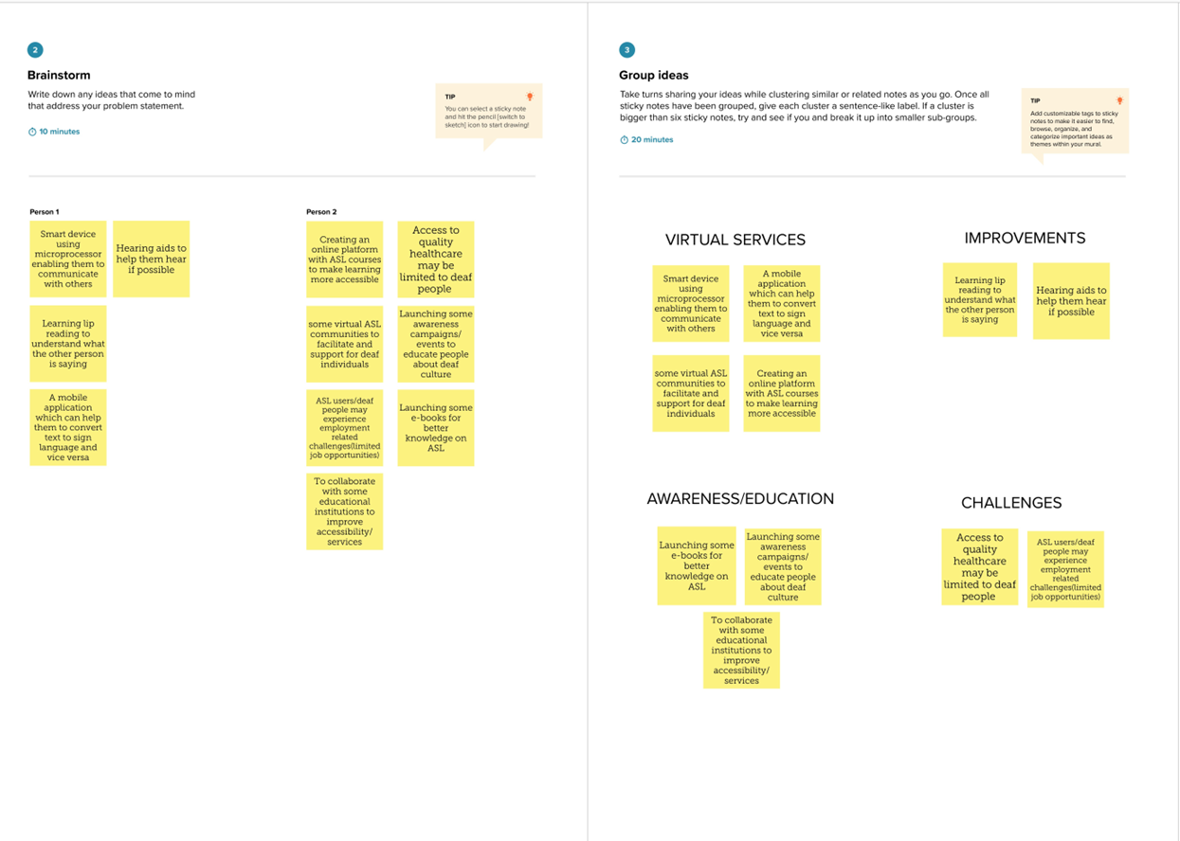

Step 3: Idea Prioritization  
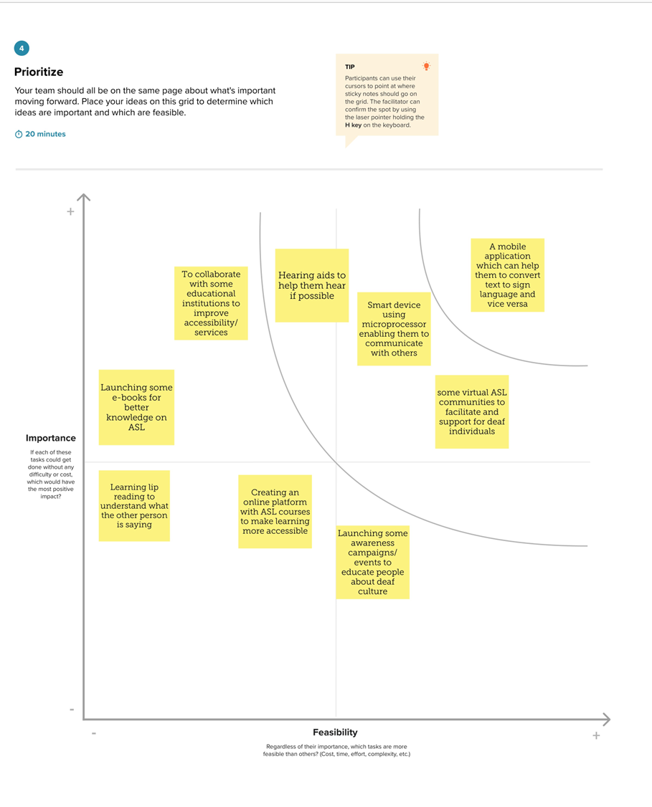

**4. REQUIREMENT ANALYSIS   
 4.1 Functional requirement   
 ASL Recognition:**

The system should accurately recognize and interpret American Sign Language gestures.

It should be able to recognize a predefined set of ASL signs and translate them into corresponding text or spoken language.

**User Interface:**

The system should have a user-friendly interface that enables easy interaction, especially for users with limited technical knowledge.

The interface should include options for users to initiate, pause, or stop the recognition process.

**Real-time Processing:**

The system should be capable of processing ASL gestures in real-time, ensuring minimal delay between the user's sign and the system's response.

**4.2 Non-Functional requirements**

**Integration with Communication Tools:**

The system should be designed to integrate seamlessly with existing communication tools and platforms, such as video conferencing applications or messaging apps.

**Multi-Gesture Recognition:**

It should support the recognition of multi-gesture sequences to capture complex expressions and sentences in ASL.

**Accessibility:**

Ensure that the user interface is accessible to individuals with varying degrees of physical abilities, including those who may use assistive technologies.

**5. PROJECT DESIGN**

**5.1 Data Flow Diagrams & User Stories**A Data Flow Diagram (DFD) is a traditional visual representation of the information flows within a system. A neat and clear DFD can depict the right amount of the system requirement graphically. It shows how data enters and leaves the system, what changes the information, and where data is stored.

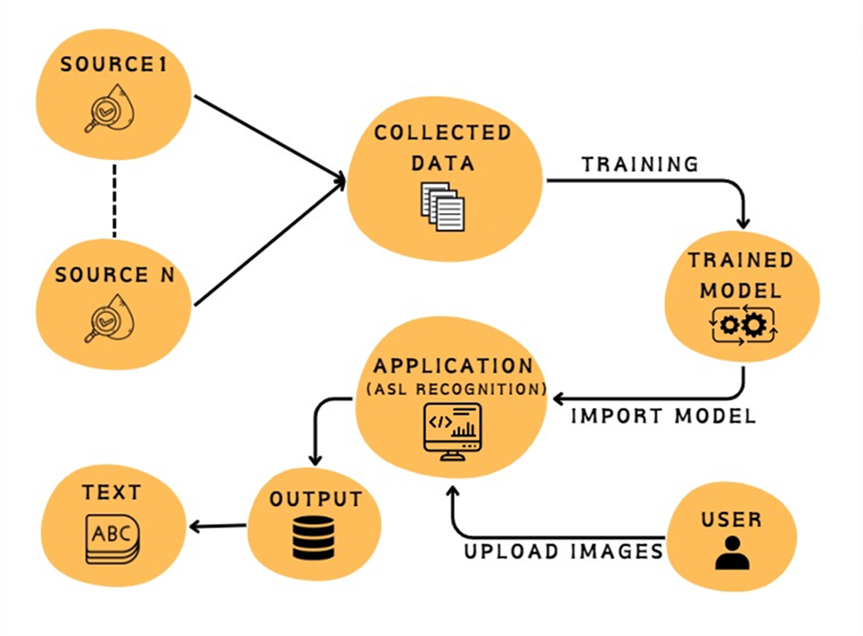

**USER STORIES:**

|  |  |  |  |  |  |  |
| --- | --- | --- | --- | --- | --- | --- |
| User Type | Functional Requirement(Epic) | User Story Number | User Story / Task | Acceptance criteria | Priority | Release |
| As a developer | Projet setup and infrastructure | USN-1 | Set up the development environment with the required tools and frameworks to start the ASL project . | Successfully configured with all necessary tools and frameworks. | High | Sprint-1 |
| As a developer | Data collection | USN-2 | Gather a diverse and large dataset of images containing all the different classes of alphabets(A, B, C, D, ….., Z), space, nothing, delete. | Gathered a diverse dataset of images (alphabets). | High | Sprint-1 |
| As a developer | Data Preprocessing | USN-3 | Preprocess the collected images by resizing and normalizing. Split the data into training and testing sets. | Preprocessed the dataset. | High | Sprint-2 |
| As a developer | Model Development | USN - 4 | Explore different deep learning architectures (CNN) to select the most suitable one for our ASL project. | Explore different DL models. | High | Sprint-2 |
| As a customer | Training | USN-5 | As a customer, I want a well trained model and very accurate predictions for the images I upload.  Task: Implement data augmentation techniques to improve model’s accuracy. | Test the model after training to check accuracy. | Medium | Sprint - 2 |
| As a developer | Integrate the ASL recognition system into applications and services. | USN - 6 | As a developer, I want the ASL recognition system to offer an API or web browser for easy accessibility. | Develop a website using HTML, CSS, JS. | Medium | Sprint - 3 |
| Customer | Develop a web-based user interface for the ASL recognition system that provides users with a simple way to interact with the system. | USN - 7 | As a customer, I want to access the ASL recognition system through a user-friendly web interface, so I can easily interact with the system without the need to install additional software | Users can access the ASL recognition system through a web browser. | High | Sprint - 3 |

**5.2 Solution Architecture**Our problem statement is - “How might we help deaf individuals communicate with the world in a better way?”  
Our solution architecture uses machine learning to provide image-based classification for the conversion of sign language to text. We are using CNN(Convolutional Neural Networks) for multi class image classification. Our model can accurately predict the 26 letters of the English alphabet, as well as three additional classes for the signs for "space", "delete", and "nothing".  
The steps in our solution architecture include:  
 ● Data gathering

● Image preprocessing

● Model building

○ Training the model

○ Testing the model

● Sign language prediction

● Website building

● Integrate sign language CNN model using Flask

● Host the website locally

○ Real time analysis

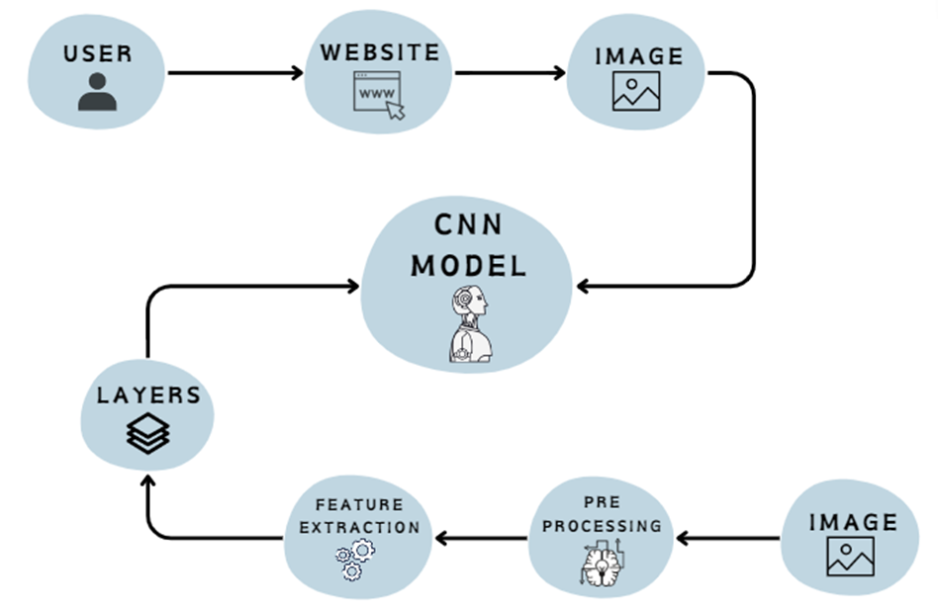

**6. PROJECT PLANNING & SCHEDULING**

**6.1 Technical Architecture**

The technical architecture shows the user interface, the integration, and the back end and how they are tied together to make the project.

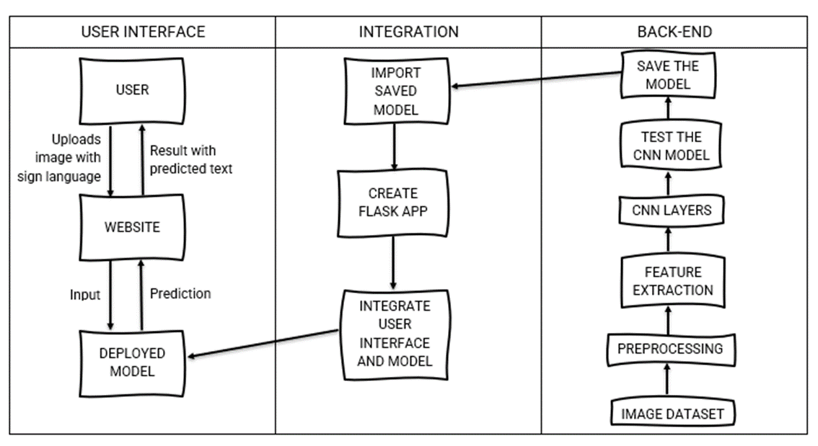

**6.2 Sprint Planning & Estimation**

|  |  |  |  |  |  |  |
| --- | --- | --- | --- | --- | --- | --- |
| **Sprint** | **Functional Requirement (Epic)** | **User Story Number** | **User Story / Task** | **Story points** | **Priority** | **Team Members** |
| Sprint-1 | Projet setup and infrastructure | USN-1 | Set up the development environment with the required tools and frameworks to start the ASL project . | 1 | High | Rishika, Sathvika |
| Sprint-1 | Data collection | USN-2 | Gather a diverse and large dataset of images containing all the different classes of alphabets(A, B, C, D, ….., Z), space, nothing, delete. | 2 | High | Rishika, Sathvika |
| Sprint-2 | Data Preprocessing | USN-3 | Preprocess the collected images by resizing and normalizing. Split the data into training and testing sets. | 3 | High | Sathvika |
| Sprint-2 | Model Development | USN - 4 | Explore different deep learning architectures to select the most suitable one(CNN) for our ASL project. | 4 | High | Rishika |
| Sprint-2 | Training | USN-5 | As a customer, I want a well trained model and very accurate predictions for the images I upload.  Task: Implement data augmentation techniques to improve model’s accuracy. | 4 | Medium | Sathvika, Rishika |
| Sprint-3 | Integrate the ASL recognition system into applications and services. | USN - 6 | As a developer, I want the ASL recognition system to offer an API or web browser for easy accessibility. | 6 | Medium | Sathvika, Rishika |
| Sprint-3 | Develop a web-based user interface for the ASL recognition system that provides users with a simple way to interact with the system. | USN - 7 | As a customer, I want to access the ASL recognition system through a user-friendly web interface, so I can easily interact with the system without the need to install additional software | 6 | High | Sathvika, Rishika |

**6.3 Sprint Delivery Schedule**

|  |  |  |  |  |  |  |
| --- | --- | --- | --- | --- | --- | --- |
| **Sprint** | **Total Story Points** | **Duration** | **Sprint Start Date** | **Sprint End Date (Planned)** | **Story Point Completed (as on Planned End Date)** | **Sprint Release Date (Actual)** |
| Sprint-1 | 3 | 3 Days | 25 Oct 2023 | 27 Oct 2023 | 3 | 27 Oct 2022 |
| Sprint-2 | 11 | 5 Days | 28 Oct 2023 | 01 Nov 2023 | 11 | 01 Nov 2023 |
| Sprint-3 | 12 | 5 Days | 02 Nov 2023 | 06 Nov 2023 | 12 | 09 Nov 2023 |

**7. CODING & SOLUTIONING (Explain the features added in the project along with code)**

**7.1 Feature 1 - User Interface :**

The UI is designed with simplicity and intuitiveness in mind, ensuring that users, regardless of technical expertise, can easily navigate and interact with the system.

The interface is designed to be simple and easy to navigate, ensuring a hassle-free experience for users.

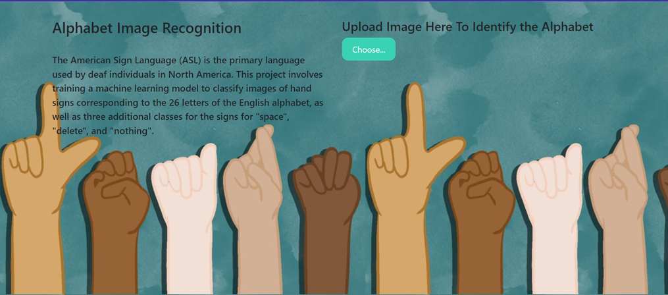

**7.2 Feature 2 - Gesture Recognition :**

The system should be able to recognize a diverse set of ASL gestures, including individual signs and multi-gesture sequences. In our project we used the Densenet121 pretrained model for better results.

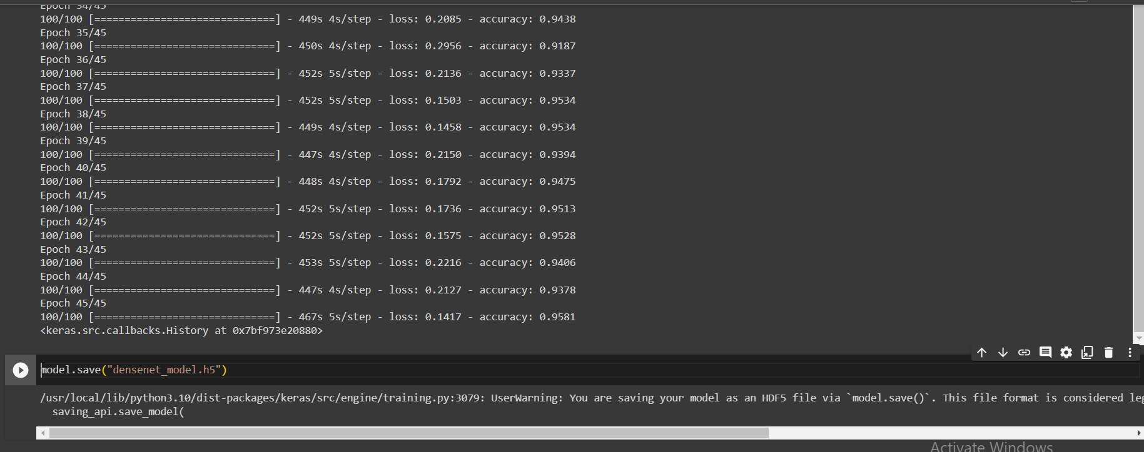

**8. PERFORMANCE TESTING**

**8.1 Performance Metrics**

|  |  |  |  |
| --- | --- | --- | --- |
| S.No. | Parameter | Values | Screenshot |
| 1. | Model Summary | Total params: 9404509  Trainable params: 2367005  Non-trainable params: 7037504 |  |
| 2. | Accuracy | Final training accuracy – 0.9581 |  |

Model Summary:  
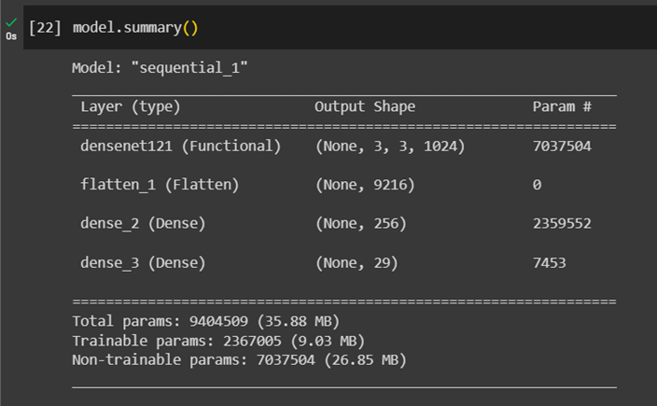Training accuracy:  
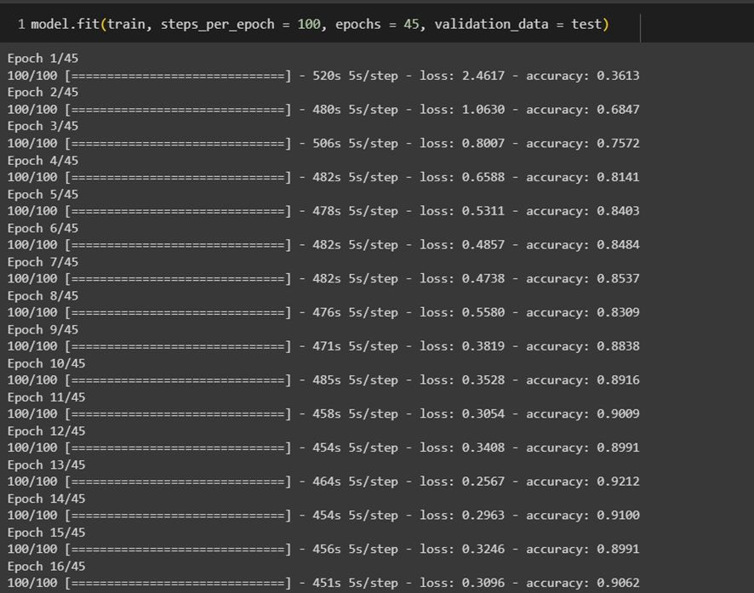

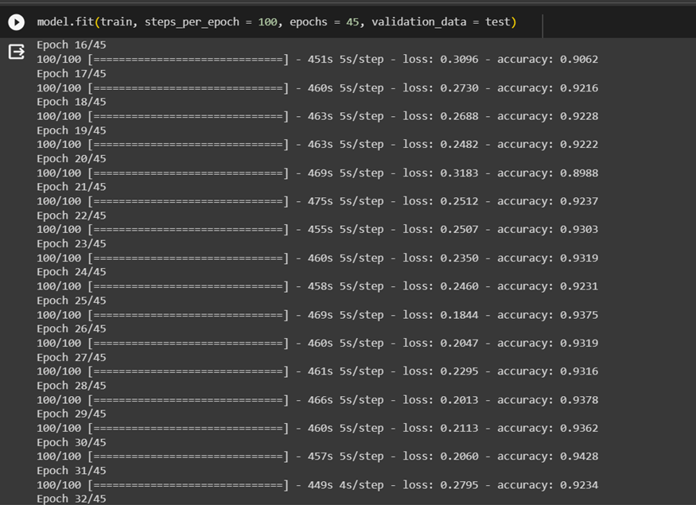

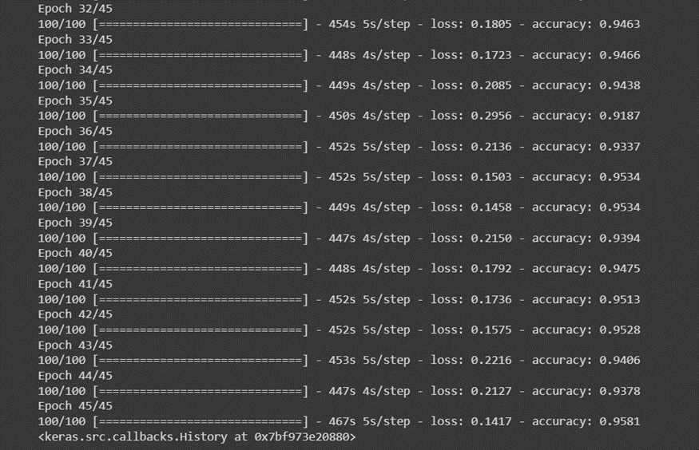

**9. RESULTS**

**9.1 Output Screenshots**

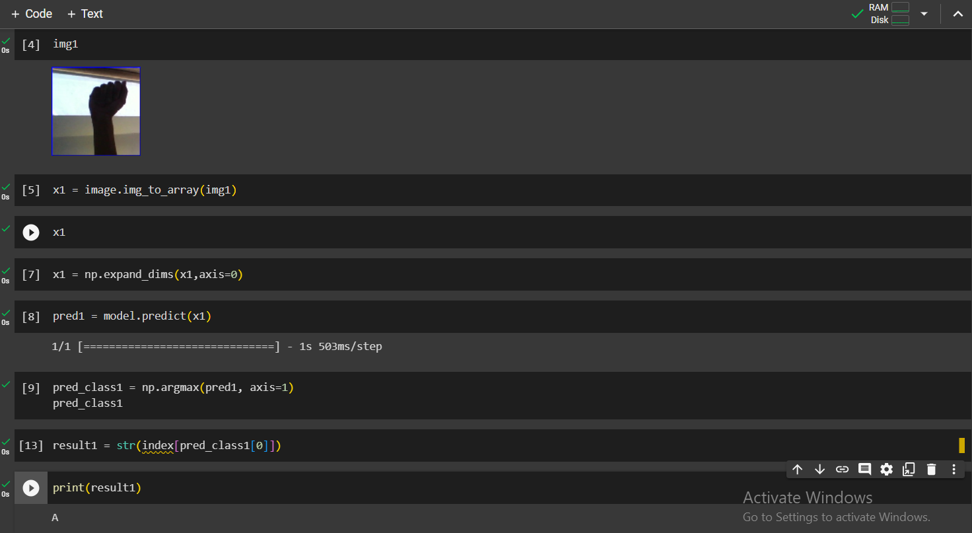

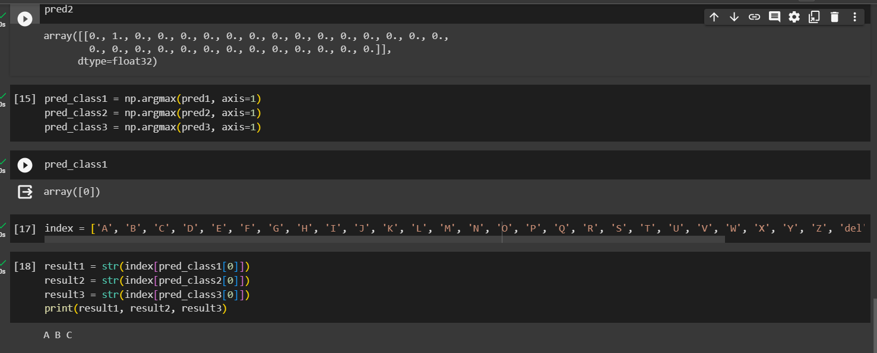

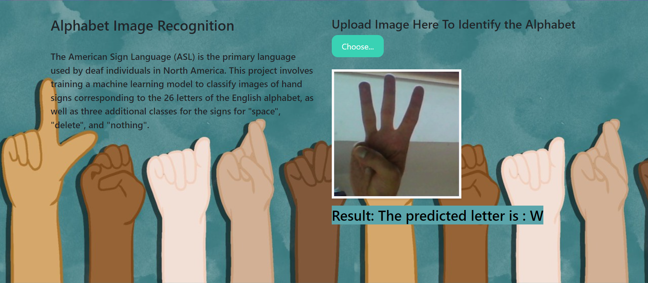

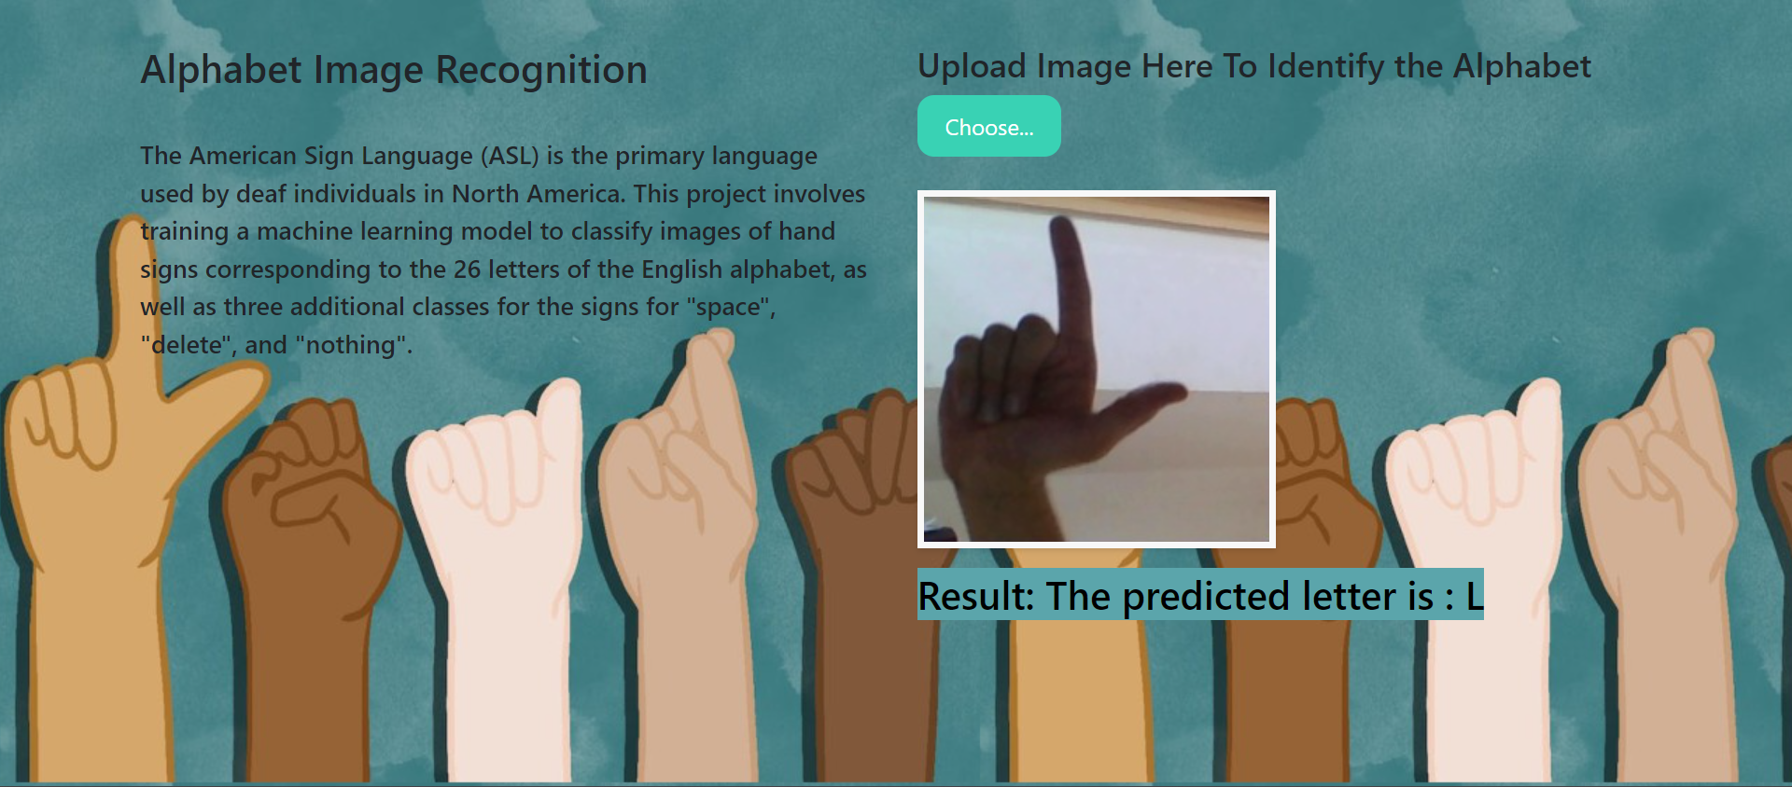

**10. ADVANTAGES & DISADVANTAGES**

**Advantages:**

1. By giving people with hearing impairments a dependable tool for deciphering American Sign Language (ASL) motions, the project greatly improves accessibility and promotes improved communication.
2. Real-time ASL gesture recognition is incorporated to provide quick and flexible interpretation, making the user experience more responsive and smooth.
3. Because of its architecture, the model can be continuously improved over time by adding more training data and incorporating user feedback, which guarantees its accuracy and adaptability.

**Disadvantages:**

1. The deep learning model's requirement for real-time processing in environments with limited resources could present difficulties, as it requires a significant amount of computational power to achieve optimal performance.
2. The vocabulary that can be used for communication is limited by the current implementation, which concentrates on a predetermined set of ASL gestures. More training and data would be needed to expand the vocabulary.
3. Deep learning models with high levels of complexity, like VGG16/Densenet121, may require more processing power during training and inference, and their length may cause these issues.
4. The model’s performance can be influenced by certain environmental conditions, such as lighting and background variations affecting accuracy in some cases.

**11. CONCLUSION**

A major step towards promoting inclusive communication for people with hearing impairments has been made with the completion of the "Sign Language Recognition using Deep Learning" project. Real-time American Sign Language (ASL) gesture recognition is implemented in this project to fulfill the urgent need for accessible tools that close communication gaps.

With the conclusion of the "Sign Language Recognition using Deep Learning" project, a significant step has been made towards encouraging inclusive communication for those with hearing impairments. This project implements real-time gesture recognition in American Sign Language (ASL) to meet the pressing need for accessible tools that bridge communication gaps.

**12. FUTURE SCOPE**

**Vocabulary Expansion:** In order to create a more complete and adaptable communication tool, future versions of the project may concentrate on increasing the vocabulary of ASL gestures that are recognised.

**Adaptive Learning:**By enabling the model to continuously change and get better based on user interactions and feedback, adaptive learning mechanisms could improve the model's performance.

**13. APPENDIX**

**Source Code - Model building**

**!pip install -q kaggle**

**!mkdir ~/.kaggle**

**!cp kaggle.json ~/.kaggle**

**!kaggle datasets download -d debashishsau/aslamerican-sign-language-aplhabet-dataset**

**!unzip /content/aslamerican-sign-language-aplhabet-dataset.zip**

**from tensorflow.keras.preprocessing.image import ImageDataGenerator**

**trainpath = "/content/ASL_Alphabet_Dataset/asl_alphabet_train"**

**testpath = "/content/ASL_Alphabet_Dataset/asl_alphabet_test"**

**train_datagen = ImageDataGenerator(rescale = 1. / 255, zoom_range = 0.2, shear_range = 0.2)**

**test_datagen = ImageDataGenerator(rescale = 1. / 255)**

**train = train_datagen.flow_from_directory(trainpath, target_size = (108, 108), batch_size = 32)**

**test = test_datagen.flow_from_directory(testpath, target_size =(108, 108), batch_size = 32)**

**train.class_indices**

**from keras.applications import DenseNet121**

**from keras.models import Sequential**

**from keras.layers import Flatten, Dense**

**from keras.optimizers import Adam**

**densenet_model = DenseNet121(weights='imagenet', include_top=False, input_shape=(108, 108, 3))**

**model = Sequential()**

**model.add(densenet_model)**

**densenet_model.trainable = False**

**model.add(Flatten())**

**model.add(Dense(256, activation='relu'))**

**model.add(Dense(29, activation='softmax'))**

**model.summary()**

**model.compile(optimizer='adam', loss='categorical_crossentropy', metrics=['accuracy'])**

**model.fit(train, steps_per_epoch = 100, epochs = 45, validation_data = test)**

**model.save("densenet_model.h5")**

**Source Code - Model testing**

**from tensorflow.keras.models import load_model**

**from tensorflow.keras.preprocessing import image**

**import numpy as np**

**model = load_model("/content/densenet_model.h5")**

**img2 = image.load_img(r"/content/B_test.jpg", target_size = (108, 108))**

**x2 = image.img_to_array(img2)**

**x2 = np.expand_dims(x2,axis=0)**

**pred2 = model.predict(x2)**

**pred_class2 = np.argmax(pred2, axis=1)**

**pred_class2**

**print(result2)**

**GitHub & Project Demo Link**

Github - <https://github.com/smartinternz02/SI-GuidedProject-613088-1698898208>

Project Demo - <https://drive.google.com/file/d/17U5NzrywPw3rNTNeUHwq0ZMYqC7e4AfK/view?usp=sharing>